**OnMouseout Events**

Design the webpage using the javascript functions like onmouseover and onmouseout events, which would produce applied effects on hovering the specific regions.

**Sample Screenshot  :**  
  
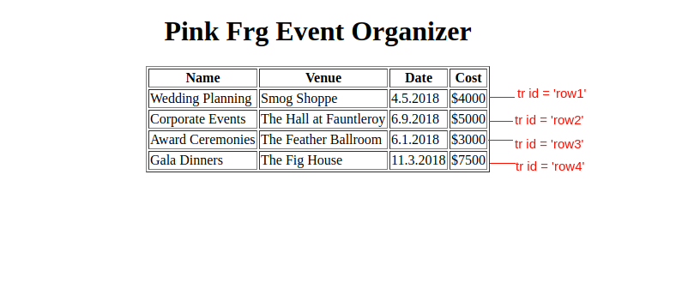  
  
**Constraints :**  
  
While hovering over the row with id 'row1' the background - color should be changed like below.  
  
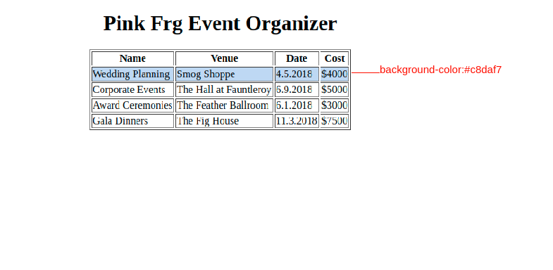  
  
While hovering over the row with id 'row2' the background-color should be changed and should remove the background-color when taking out the mouse from the row, like below.  
  
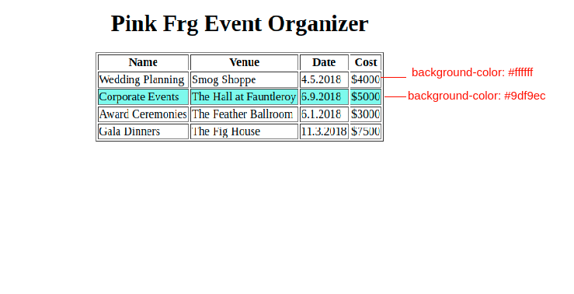  
  
While hovering over the row with id 'row3' the background - color should be changed like below.  
  
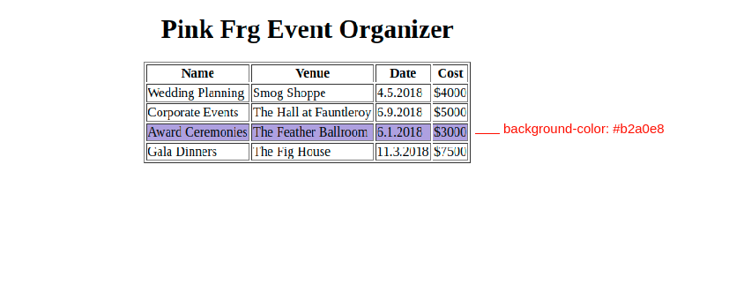  
  
While hovering over the row with id 'row4' the background - color should be changed like below.  
  
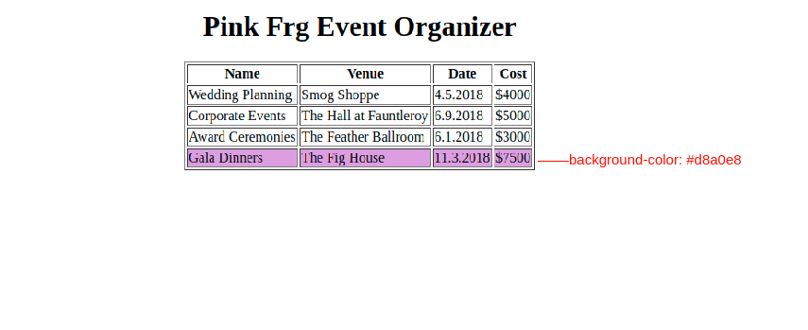  
  
**Additional Constraints:**

* Refer to the screenshots for the HTML specifications
* While hovering each row should be filled with different colors
* Use event objects for color change of the particular row
* Kindly don't change the color codes.

**Note :**  
  
Content of the page should be present as shown in the screenshot.  
Kindly refer to the content which is given as a part of the description.  
  
**Content :**  
  
Given as a part of the template kindly refer to it.  
  
**For id row1**  
For performing hover function - 'hoverRow1( )'  
backgroundcolor - '#c8daf7'  
For bring back to its orginal state - 'removeHover1( )'  
backgroundcolor  - '#ffffff'  
  
**For id row2**  
For performing hover function - 'hoverRow2( )'  
backgroundcolor - '#9df9ec'  
For bring back to its orginal state - 'removeHover2( )'  
backgroundcolor - '#ffffff'  
  
**For id row3**  
For performing hover function - 'hoverRow3( )'  
backgroundcolor - '#b2a0e8'  
For bring back to its orginal state - 'removeHover3( )'  
backgroundcolor - '#ffffff'  
  
**For id row4**  
For performing hover function - 'hoverRow4( )'  
backgroundcolor - '#d8a0e8'  
For bring back to its orginal state - 'removeHover4( )'  
backgroundcolor - '#ffffff'